Worksheet on Autonomous Vehicles

Justification of decision

If difficult to decide, explain why

Test Case 1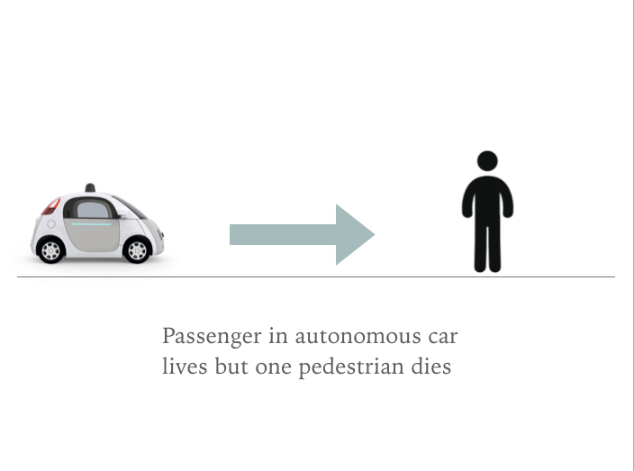

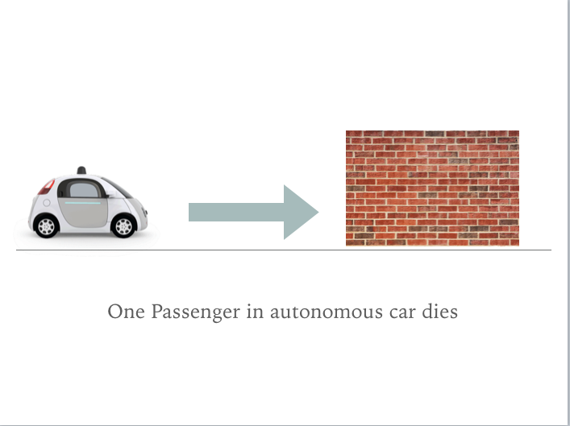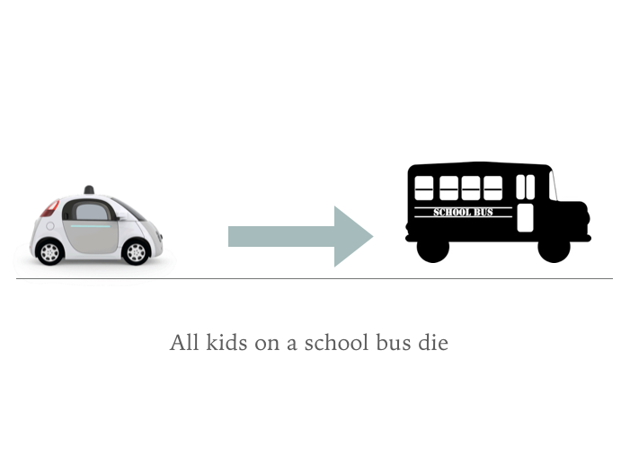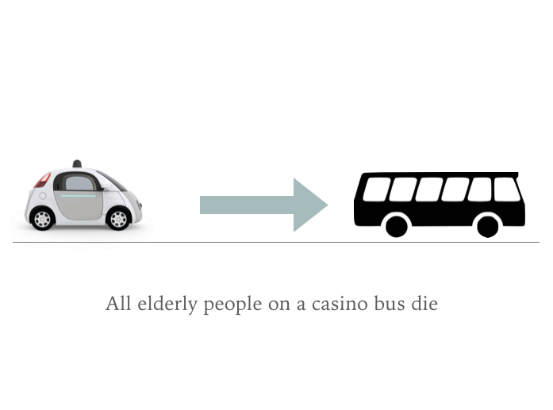

Versus

Test Case 2

Justification of decision

If difficult to decide, explain why

Versus

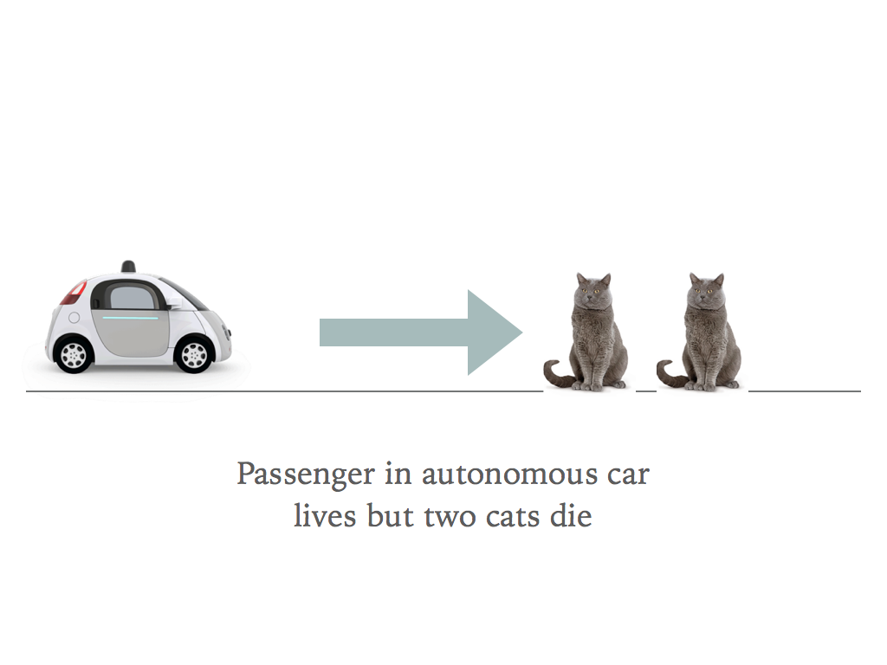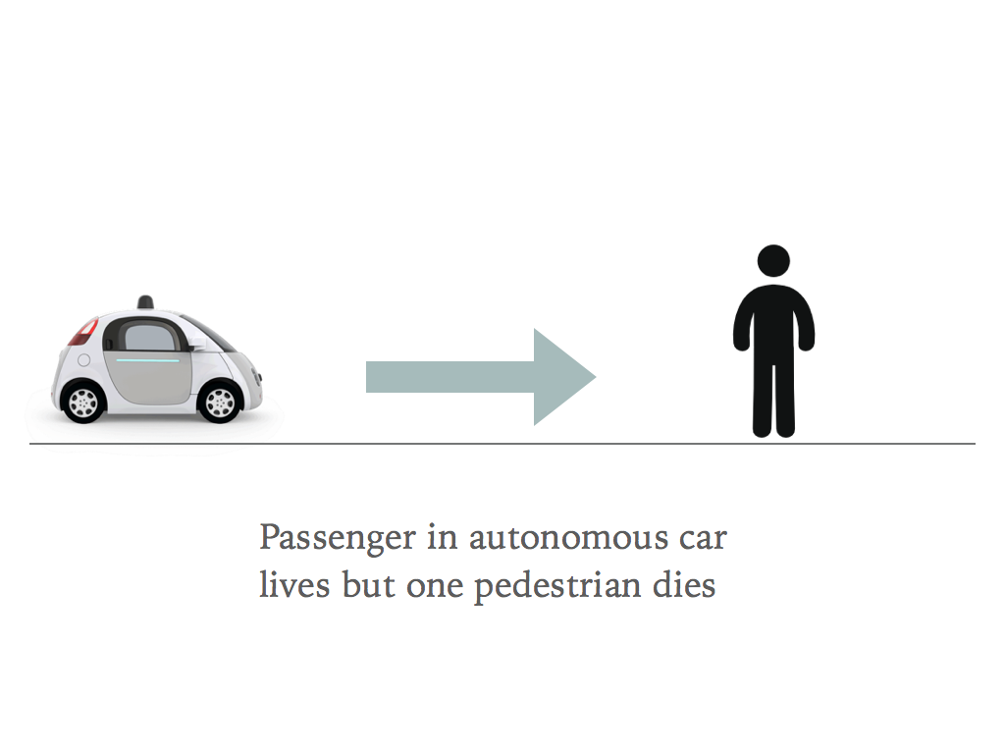

Test 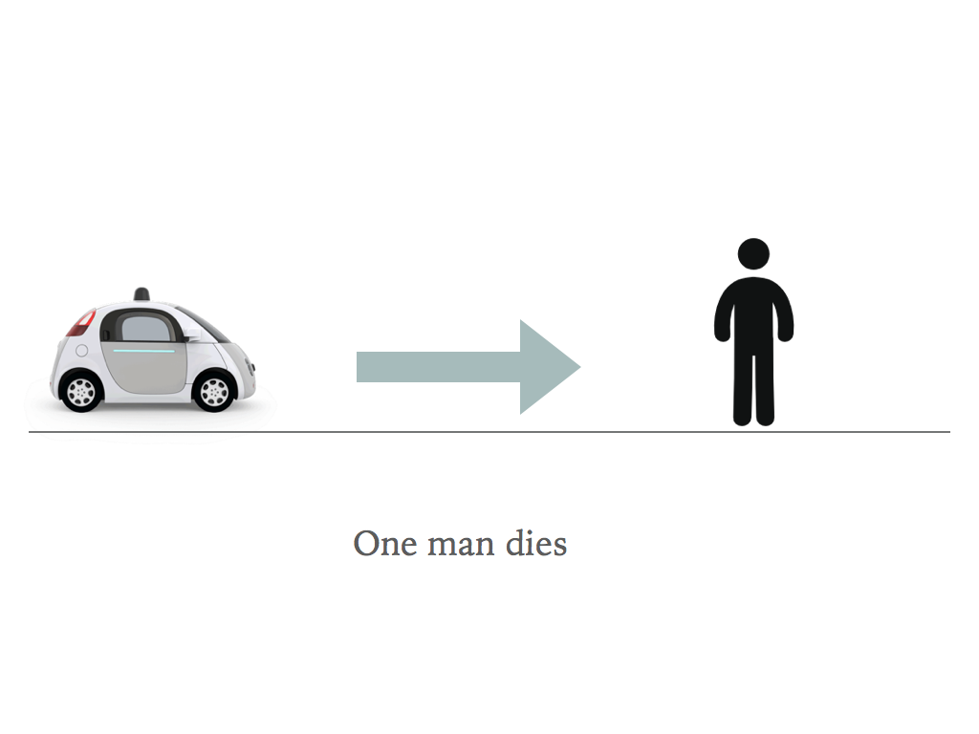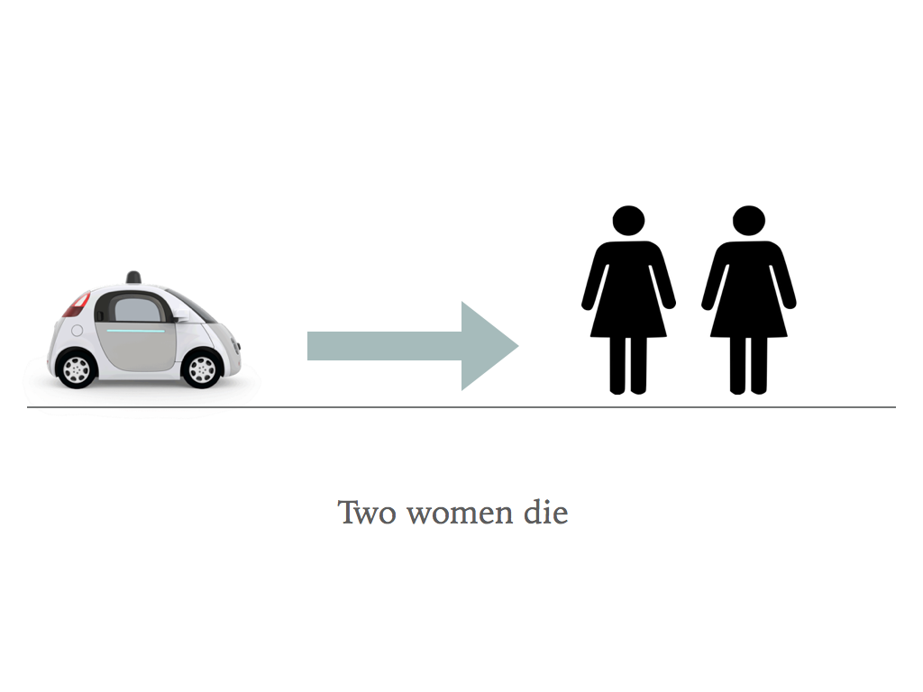Case 3

Versus

Justification of decision

If difficult to decide, explain why

Test 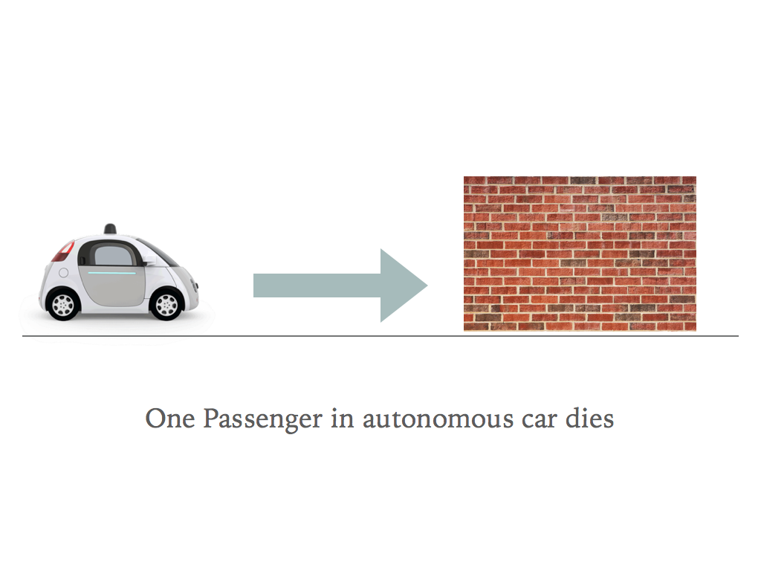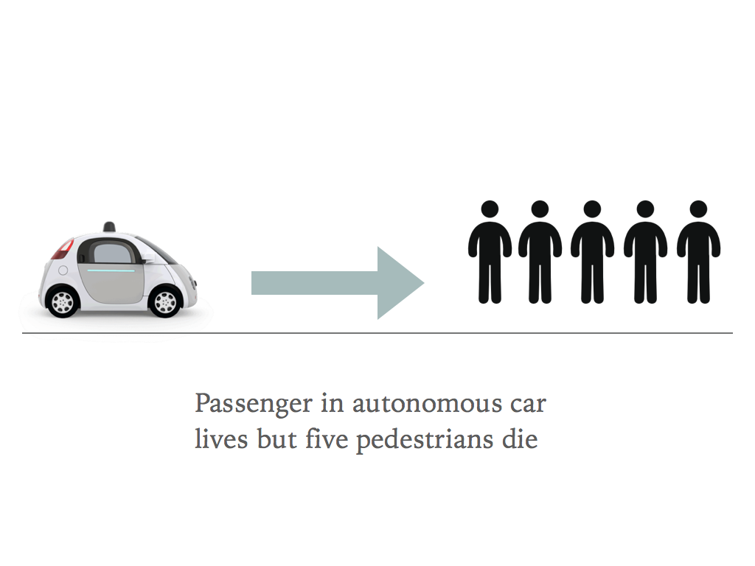Case 4

Versus

Justification of decision

If difficult to decide, explain why

Test Case 5

Versus

Justification of decision

If difficult to decide, explain why

Test 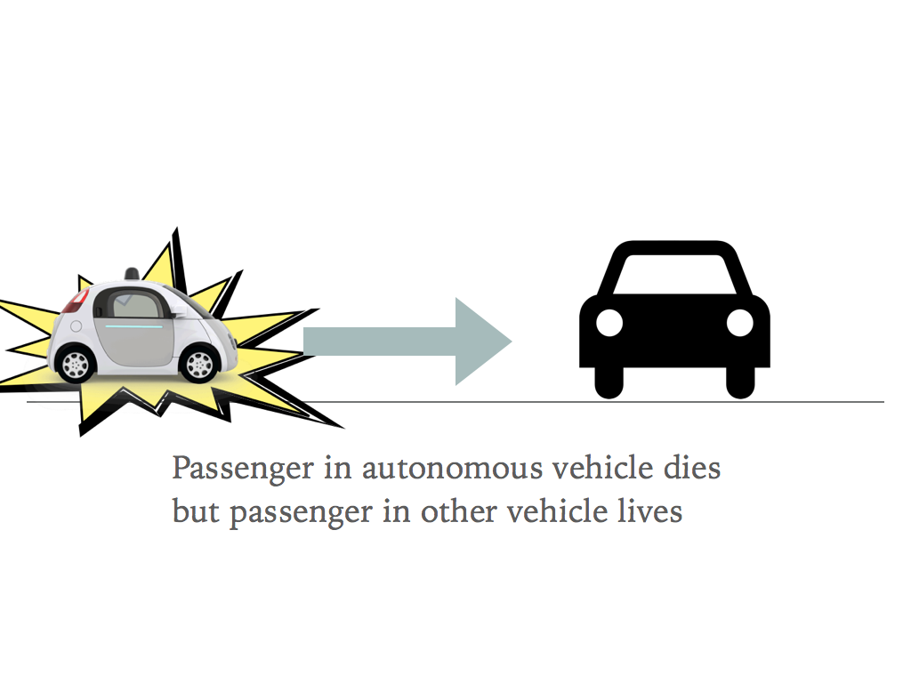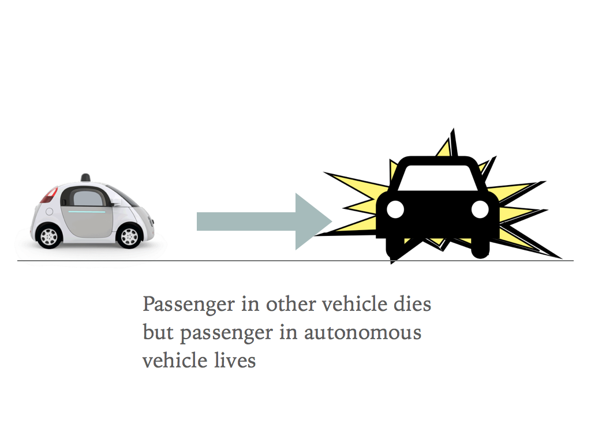Case 6

Versus

Justification of decision

If difficult to decide, explain why

Test 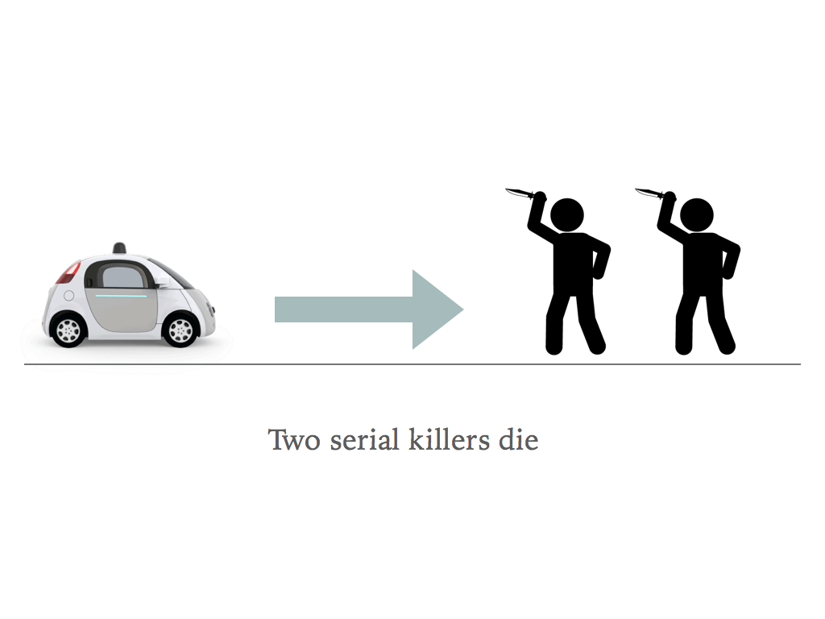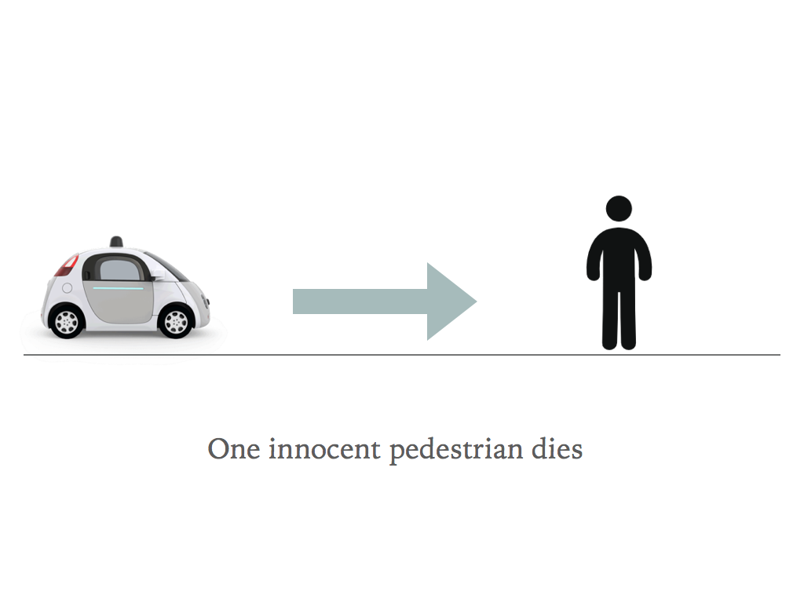Case 7

Versus

Justification of decision

If difficult to decide, explain why

Test 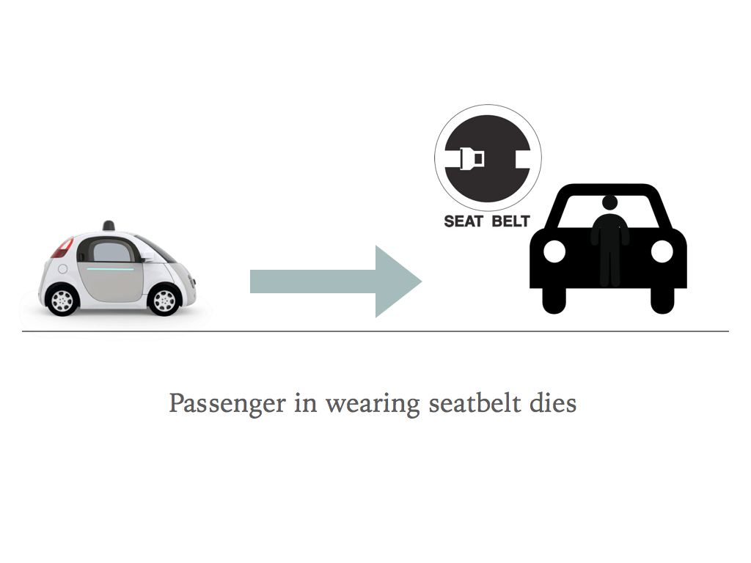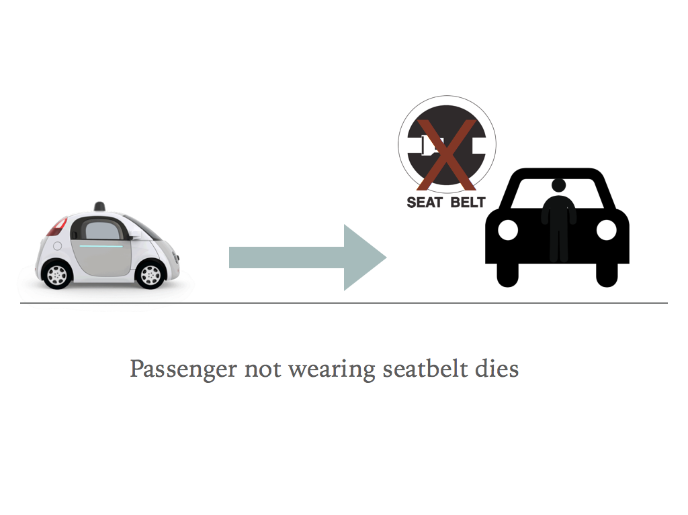Case 8

Versus

Justification of decision

If difficult to decide, explain why

Create Your Own Test Case

Versus

Justification of decision

If difficult to decide, explain why

Create Your Own Test Case

Versus

Justification of decision

If difficult to decide, explain why